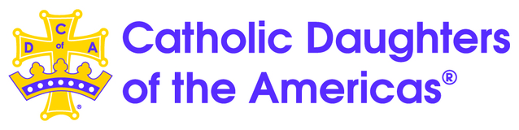
COURT COMPTON #942
100TH ANNIVERSARY CRUISE FUNDRAISER*
Carnival Firenze
JOIN YOUR CDA SISTERS FOR A FUN TIME OF FRIENDSHIP AND FUN!
MAY 30 – JUNE 4, 2024 (BOOKING #Z8J7D4)
Day | Port of Call | Arrival Time | Depart Time
Thu | Los Angeles (Long Beach) |  | 04:00 PM
Fri | FUN DAY AT SEA
Sat | Cabo San Lucas | 10:00 AM | 06:00 PM
Sun | FUN DAY AT SEA
Mon | Ensenada | 08:00 AM | 05:00 PM
Tue | Los Angeles (Long Beach) | 08:00 AM

Rates good until 12/15/23 -($150 per person DEPOSIT required to book your CABIN)
CABIN | RATE PP | TAX | TOTAL COST | NOTES
INTERIOR | $383.00 PP | $246.65 PP | $647.85 PP  ($1,295.70) | DECK 6 & 7  2- 4C Cabins on hold
BALCONY | $583.00 PP | $246.65 PP | $829.85 PP  ($1.659.70) | DECK 6 & 7  16 (8B & 8C on hold)
42 CABINS | On hold
Final Deadline MARCH 16, 2024
*Note: All money (commission) earned from this booking will go into our CDA 100TH Anniversary fund. Great Christmas Gift!
YVONNE IRALDO, NEXION TRAVEL ADVISOR 310) 678-9389 (YMIRALDO@YAHOO.COM)

File: CDA 100TH ANNIVERSARY FLYER
CLIENT WORKSHEET REQUEST FOR CRUISE BOOKING
PLEASE COMPLETE AND RETURN TO ME ASAP (ymiraldo@yahoo.com)
PASSENGER(S) M/status MAILING ADDRESS TELEPHONE # DATE OF BIRTH

- _ __________________________________________________________________________

- ________________________________ _________________ __________________________

- ________________________________ _________________ __________________________

PAST GUEST VIFP #: _________ ONE CABIN ( ) 2 IN A CABIN (X ) 3 IN A CABIN ( ) 4 IN A CABIN ( )

CREDIT CARD # __ __________________ EXP. DATE ______ CVV # _ ____ ZIP CODE __________

NAME ON CC: ______________________________________ PHONE #: ____________________

AMOUNT AUTHORIZED TO CHARGE: _$_150.00 PP (TO BERTH YOUR CABIN)_
Due by
CLIENT EMAIL ADDRESS: _______ _____________________________

SCAN COMPLETED WORKSHEET TO: YMIRALDO@YAHOO.COM

CRUISE SHIP/Line: _ Carnival Firenze SAILING DATE _5/30/24 GROUP Booking # Z8J7D4

CABIN CATEGORY [ ] INTERIOR [ ] BALCONY DECK____ __ BOOKING NBR: __ _______

DINING TIME: _ANYTIME DINING_ [ ] OR 1ST SITTING [ ] 2ND SITTING [ ]
With the Group

TRAVEL INSURANCE PURCHASED? YES [ ] NO [ ]

CANCELLATION PENALTIES/REFUND ADVISED? ______ CLIENT HAS PASSPORT? Y / N

PROOF OF CITIZENSHIP/DOCUMENTATION ADVISED ______ EMBARKATION PORT_Long Beach_

S/P Needs Y / N _________ Dietary Y / N ______ PROMOTION: ON BOARD CREDIT $_______

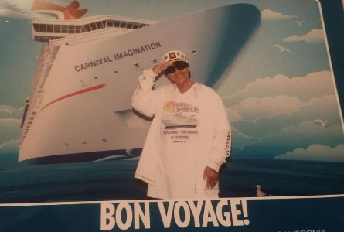  Yvonne, Nexion Agent.  310) 678-9389 | Deposit due now: $150.00 PP ($300 to berth cabin) DUE BY 12/14/23 Final Pymt. Due: 3/16/2024  Monthly Payment Schedule: (0ptional – 5 Months Paid in Full)  OCT. (Deposit) NOV. DEC. JAN. FEB. MAR. BAL.  $300  Final Pymt. Due: 3/16/2024

